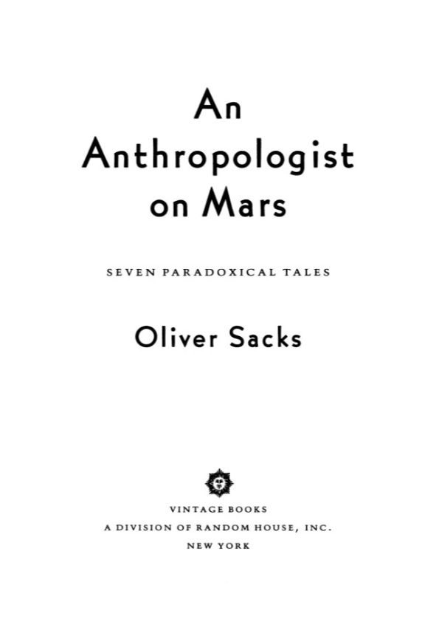

Preface
I am writing this with my left hand, although I am strongly right-handed. I had surgery to my right shoulder a month ago and am not permitted, not capable of, use of the right arm at this time. I write slowly, awkwardly—but more easily, more naturally, with each passing day. I am adapting, learning, all the while—not merely this left-handed writing, but a dozen other left-handed skills as well: I have also become very adept, prehensile, with my toes, to compensate for having one arm in a sling. I was quite off balance for a few days when the arm was first immobilized, but now I walk differently, I have discovered a new balance. I am developing different patterns, different habits—a different identity, one might say, at least in this particular sphere. There must be changes going on with some of the programs and circuits in my brain—altering synaptic weights and connectivities and signals (though our methods of brain imaging are still too crude to show these). Though some of my adaptations are deliberate, planned, and some are learned through trial and error (in the first week I injured every finger of my left hand), most have occurred by themselves, unconsciously, by reprogrammings and adaptations of which I know nothing (any more than I know, or can know, how I normally walk). Next month, if all goes well, I can start to readapt again, to regain a full (and “natural”) use of the right arm, to reincorporate it back into my body image, myself, to become a dexterous, dextral human being once again.
But recovery, in such circumstances, is by no means automatic, a simple process like tissue healing—it will involve a whole nexus of muscular and postural adjustments, a whole sequence of new procedures (and their synthesis), learning, finding, a new path to recovery. My surgeon, an understanding man who has had the same operation himself, said, “There are general guidelines, restrictions, recommendations. But all the particulars you will have to find out for yourself.” Jay, my physiotherapist, expressed himself similarly: “Adaptation follows a different path in each person. The nervous system creates its own paths. You’re the neurologist—you must see this all the time.”
Nature’s imagination, as Freeman Dyson likes to say, is richer than ours, and he speaks, marvellingly, of this richness in the physical and biological worlds, the endless diversity of physical forms and forms of life. For me, as a physician, nature’s richness is to be studied in the phenomena of health and disease, in the endless forms of individual adaptation by which human organisms, people, adapt and reconstruct themselves, faced with the challenges and vicissitudes of life.
Defects, disorders, diseases, in this sense, can play a paradoxical role, by bringing out latent powers, developments, evolutions, forms of life, that might never be seen, or even be imaginable, in their absence. It is the paradox of disease, in this sense, its “creative” potential, that forms the central theme of this book.
Thus while one may be horrified by the ravages of developmental disorder or disease, one may sometimes see them as creative too—for if they destroy particular paths, particular ways of doing things, they may force the nervous system into making other paths and ways, force on it an unexpected growth and evolution. This other side of development or disease is something I see, potentially, in almost every patient; and it is this, here, which I am especially concerned to describe.
Similar considerations were brought up by A.R. Luria, who, more than any other neurologist in his lifetime, studied the long-term survival of patients who had cerebral tumors or had suffered brain injuries or strokes—and the ways, the adaptations, they used to survive. He also studied deaf and blind children as a very young man (with his mentor L.S. Vygotsky). Vygotsky stressed the intactness rather than the deficits of such children:
A handicapped child represents a qualitatively different, unique type of development—If a blind or deaf child achieves the same level of development as a normal child, then the child with a defect achieves this in another way, by another course, by other means—, and, for the pedagogue, it is particularly important to know the uniqueness of the course along which he must lead the child. This uniqueness transforms the minus of the handicap into the plus of compensation.
That such radical adaptations could occur demanded, Luria thought, a new view of the brain, a sense of it not as programmed and static, but rather as dynamic and active, a supremely efficient adaptive system geared for evolution and change, ceaselessly adapting to the needs of the organism—its need, above all, to construct a coherent self and world, whatever defects or disorders of brain function befell it. That the brain is minutely differentiated is clear: there are hundreds of tiny areas crucial for every aspect of perception and behavior (from the perception of color and of motion to, perhaps, the intellectual orientation of the individual). The miracle is how they all cooperate, are integrated together, in the creation of a self. ¹

^{1.} This, indeed, is the problem, the ultimate question, in neuroscience—and it cannot he answered, even in principle, without a global theory of brain function, one capable of showing the interactions of every level, from the micropatterns of individual neuronal responses to the grand macropatterns of an actual lived life. Such a theory, a neural theory of personal identity, has been proposed in the last few years by Gerald M. Edelman, in his theory of neuronal group selection, or “neural Darwinism.”

This sense of the brain’s remarkable plasticity, its capacity for the most striking adaptations, not least in the special (and often desperate) circumstances of neural or sensory mishap, has come to dominate my own perception of my patients and their lives. So much so, indeed, that I am sometimes moved to wonder whether it may not be necessary to redefine the very concepts of “health” and “disease”, to see these in terms of the ability of the organism to create a new organization and order, one that fits its special, altered disposition and needs, rather than in the terms of a rigidly defined “norm.”
Sickness implies a contraction of life, but such contractions do not have to occur. Nearly all of my patients, so it seems to me, whatever their problems, reach out to life—and not only despite their conditions, but often because of them, and even with their aid.
Here then are seven narratives of nature—and the human spirit—as these have collided in unexpected ways. The people in this book have been visited by neurological conditions as diverse as Tourette’s syndrome, autism, amnesia, and total colorblindness. They exemplify these conditions, they are “cases” in the traditional medical sense—but equally they are unique individuals, each of whom inhabits (and in a sense has created) a world of his own.
These are tales of survival, survival under altered, sometimes radically altered, conditions—survival made possible by the wonderful (but sometimes dangerous) powers of reconstruction and adaptation we have. In earlier books I wrote of the “preservation” of self, and (more rarely) of the “loss” of self, in neurological disorders. I have to come to think these terms too simple—and that there is neither loss nor preservation of identity in such situations, but, rather, its adaptation, even its transmutation, given a radically altered brain and “reality.”
The study of disease, for the physician, demands the study of identity, the inner worlds that patients, under the spur of illness, create. But the realities of patients, the ways in which they and their brains construct their own worlds, cannot be comprehended wholly from the observation of behavior, from the outside. In addition to the objective approach of the scientist, the naturalist, we must employ an intersubjective approach too, leaping, as Foucault writes, “into the interior of morbid consciousness, [trying] to see the pathological world with the eyes of the patient himself.” No one has written better of the nature and necessity of such intuition or empathy than G.K. Chesterton, through the mouth of his spiritual detective, Father Brown. Thus when Father Brown is asked for his method, his secret, he replies:
Science is a grand thing when you can get it; in its real sense one of the grandest words in the world. But what do these men mean, nine times out of ten, when they use it nowadays? When they say detection is a science? When they say criminology is a science? They mean getting outside a man and studying him as if he were a gigantic insect; in what they would call a dry impartial light; in what I should call a dead and dehumanized light. They mean getting a long way off him, as if he were a distant prehistoric monster; staring at the shape of his “criminal skull” as if it were a sort of eerie growth, like the horn on a rhinoceros’s nose. When the scientist talks about a type, he never means himself, but always his neighbour; probably his poorer neighbour. I don’t deny the dry light may sometimes do good; though in one sense it’s the very reverse of science. So far from being knowledge, it’s actually suppression of what we know. It’s treating a friend as a stranger, and pretending that something familiar is really remote and mysterious. It’s like saying that a man has a proboscis between the eyes, or that he falls down in a fit of insensibility once every twenty-four hours. Well, what you call “the secret” is exactly the opposite. I don’t try to get outside the man. I try to get inside.
The exploration of deeply altered selves and worlds is not one that can be fully made in a consulting room or office. The French neurologist François Lhermitte is especially sensitive to this, and instead of just observing his patients in the clinic, he makes a point of visiting them at home, taking them to restaurants or theaters, or for rides in his car, sharing their lives as much as possible. (It is similar, or was similar, with physicians in general practice. Thus when my father was reluctantly considering retirement at ninety, we said, “At least drop the house calls.” But he answered, “No, I’ll keep the house calls—I’ll drop everything else instead.”)
With this in mind, I have taken off my white coat, deserted, by and large, the hospitals where I have spent the last twenty-five years, to explore my subjects’ lives as they live in the real world, feeling in part like a naturalist, examining rare forms of life,—in part like an anthropologist, a neuroanthropologist, in the field—but most of all like a physician, called here and there to make house calls, house calls at the far borders of human experience.
These then are tales of metamorphosis, brought about by neurological chance, but metamorphosis into alternative states of being, other forms of life, no less human for being so different.

O.W.S.
New York, June 1994

